**OBJECTS, MATERIALS, PROPERTIES**

**Task 1A Listen and learn the vocabulary below.** <http://www.languageguide.org/english/vocabulary/car/>

**CAR PARTS**

|  |  |
| --- | --- |
| 1. accelerator 2. blinker 3. brakes 4. bumper 5. clutch 6. door 7. fuel gauge 8. funnel 9. gas can 10. gearshift 11. gears 12. headlight 13. hood 14. hubcap 15. jack 16. jumper cables | 1. license plate 2. muffler 3. pedals 4. rear-view mirror 5. shock absorber 6. spark plug 7. speedometer 8. steering wheel 9. taillight 10. tire 11. tread 12. trunk 13. wheel 14. windshield wiper (wiper) 15. windshield |

|  |  |  |  |  |  |  |  |  |  |
| --- | --- | --- | --- | --- | --- | --- | --- | --- | --- |
| **Task 1B Name the car parts.** **The first one has been done for you.**   |  |  | | --- | --- | |  | 1. Hood | |  | |  | |  | |  | |  | |  | |  | |

**Task 1C Name more parts.**

|  |  |  |  |  |  |  |  |  |  |  |  |  |  |  |  |  |  |  |  |  |  |  |  |  |
| --- | --- | --- | --- | --- | --- | --- | --- | --- | --- | --- | --- | --- | --- | --- | --- | --- | --- | --- | --- | --- | --- | --- | --- | --- |
| |  |  | | --- | --- | |  |  | |  |  | |  |  | |  |  | |  |  | |  |  | |  |  | |  |  | |  |  | |  |  | |  |  | |  |  | |

(Pictures from <http://www.languageguide.org/im/car/eng/> )

**2. ENGINEERING MATERIALS**

**Task 2A Which of the following materials are used for which parts of a modern car? Give examples.**

|  |  |
| --- | --- |
| **aluminum** |  |
| **copper** |  |
| **lead** |  |
| **ceramics** |  |
| **iron** |  |
| **glass** |  |
| **plastics** |  |
| **fiberglass** |  |
| **alloy** |  |
| **steel** |  |

**It’s very important in engineering to find the most suitable material(s) for certain objects. That’s why we need to know the properties of the material that we intend to use.**

**Task 2B Below is a chart of** the **groups of materials. Supply the chart with the following materials:**

|  |  |  |  |  |  |  |
| --- | --- | --- | --- | --- | --- | --- |
| **leather** | **gold** | **aluminium** | **styrofoam/**  **polysytrene** | **silver** | **glass** | **stone** |
| **wool** | **plastics** | **synthetics** | **porcelain** | **lead** | **steel** | **cast iron** |

|  |  |  |  |  |  |  |  |
| --- | --- | --- | --- | --- | --- | --- | --- |
| **METALS** | | | | **NON-METALS** | | | |
| **FERROUS**  **METALS** | | **NON-FERROUS** | | **NATURAL MATERIALS** | | **ARTIFICIAL MATERIALS** | |
|  |  | **heavy metals:** | **light metals:** | wood |  | **ceramic material** |  |
|  |  |  |  |  |  |  |  |
|  |  |  |  |  |  |  |  |

**Task 2C Fill in the text with the words in the box.**

|  |  |  |
| --- | --- | --- |
| **ore** | **porcelain** | **furnace** |
| **soft** | **composite** | **alloy** |
| **carbon** | **stone** | **ferrous** |
| **insulator** | **conductor** | **temperatures** |
| **lead** | **melting point** | **sintered-powder** |
|  | **fiberglass** |  |

1. At first, natural materials such as wood or ______________________ were used.
2. About 9000 years ago copper was discovered. This is a very __________________ material and it could easily be worked with a stone hammer.
3. **_______________** and copper belong to non-ferrous materials. About 5500 years ago man was able to melt copper out of copper ________________.
4. **______________________**metals were produced later when the _______________________ had been invented. This produced enough heat to melt iron ore. Iron has a much higher ________________________ than copper.
5. Steel was invented with the discovery that adding _______________________ improved the properties of iron.
6. The processing of metals went hand in hand with the production of ceramics such as glass and _____________________. Here too, high _______________________ are needed.
7. Modern materials include ________________________materials, consisting of a metal powder that is subjected to high pressure and then heated, and _________________________materials, which are made of two or more different materials, the examples of such materials being reinforced concrete or __________________ -reinforced synthetics.
8. An _________________is a metal that is formed by mixing other metals or elements.
9. A ______________________ allows heat or current to flow easily.
10. An ___________________ does not allow heat or current to flow easily.

**ALLOYS** 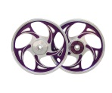

**Task 2D What’s an alloy? Watch the video and fill in the gaps.**

<http://www.youtube.com/watch?v=9LHDSB1n11k> 6,45 min (only first 2,45 min)

Almost every piece of metal we use in our life is an __________________, whether it’s the wheels of our cars, the ____________________ we eat with, and even the jewelry we wear. But what are alloys and how are they made?

Alloys essentially are _____________________ of the base metal and one or more additional elements.

Combining metals like this produces a material with very different properties to the individual metals on their own.

And this technology isn’t new. In fact, humans have been using alloys for 1000s of years.

**Task 2E Listen on and finish the chart below.**

|  |  |  |  |
| --- | --- | --- | --- |
| **ALLOY** |  |  | P**RODUCTS** |
| bronze | copper |  | tools, weapons, pots |
|  | lead | tin | connecting electronic components, joining pipes |
| steel | iron |  | bridges |
|  | steel | chromium | cutlery, car parts |
| nickel-aluminium | nickel  (is light, has high melting point) | (light and strong) | jet turbine blades |

**Task 2F Read and fill in the gaps with keywords provided.**

|  |  |  |
| --- | --- | --- |
| **brass** | **pure** | **resistant** |
| **goldsmiths** | **unsuitable** | **to lower** |
| **corrode** | **to cast** | **weak** |

**___________ metals** are often _______________________ and ________________________ **easily**, but their properties can be improved by mixing them with other metals or non-metals. The mixture of two or more metals is called an alloy.

**Pure copper**, for example, is very soft, but if you mix it with tin, you can produce a much harder material and _______________________ the melting point of the metals, which makes it easier to ___________________. This alloy is called bronze.

**____________________** is also an alloy, it contains zinc instead of tin.

**Steel** is an alloy of iron and carbon. It is harder than pure iron and much more ______________________ to corrosion. If you add a certain amount of silicon and a little carbon to iron, you get steel with a high electrical resistance.

**Aluminum** alloy are used in the construction of airplanes, automobiles, bicycles and buildings. Pure aluminum parts corrode too easily, so they are ___________________________ for use in airplanes and buildings. Pure gold and silver are often too soft to be used in jewelry or in dental applications, e.g. for inlays or crowns, so ___________________________ and dentists use alloys instead.

*Adapted from:Technical Milestones ( English fur technische Berufe, Klett)*

**STEEL**  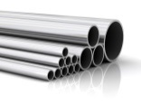

Steel is the most widely used engineering material. Technically, though, this well-known alloy of iron and carbon is not as simple as one might think. Steel comes in a huge range of different grades, each with different characteristics.

The first, **carbon steels**, consist of iron and carbon, and contain no significant quantities of other metals. **Mild steel**- containing about 0.3% carbon, **medium and high carbon steel** which contain approximately 0.6 to 1.4% carbon.

The second are **alloy steels**, which consists of iron, carbon and one or more alloying metals ( chromium, nickel, manganese, vanadium); **stainless steels** containing chromium and nickel and do not rust; **tool steels** are extremely hard, and are used in cutting tools. They contain tungsten and/or cobalt. (high-speed steel is used in cutting tools that operate at high temperatures, such as drill bits).

**The biggest weakness of steel is that it corrodes**- its surface **progressively deteriorates** due to a chemical reaction. If steel is not protected properly, **a rusty layer ‘eats’ into the metal**.

<http://www.youtube.com/watch?v=mRA6RY2o9Lg> How it’s made: steel 4,51 min

<http://www.youtube.com/watch?v=9l7JqonyoKA> 6,45 min; Steel, from start to finish

**Task 2E Complete the table with the words related to corrode, oxide and rust. Then make up 3 sentences using those words.**

|  |  |  |
| --- | --- | --- |
| **Verb** | **Adjective** | **Noun** |
| oxidize |  | oxygen |
| corrode | corroded |  |
| rust/go rusty |  | rust |
| expand | expanding |  |
|  | contracting | contraction |
|  | | |
|  | | |
|  | | |

**Task 2F Watch the video about LTH Castings, the company on Litostrojska, just opposite our school and write a short presentation of the company.**

<http://www.lthcastings.com/> 10 min presentation

**Task 2G**

**CERAMICS 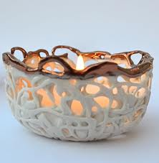 Fill in the gaps.**

It is not only pottery or dentistry. It is widely used in **modern industry for high-tech applications**, such as **e_________________ c___________________**, **j_________________** and **c______________ t________________** as well as in households and in dentistry. It has high electrical conductivity, enduring utility, mechanical strength, hardness, resistance to wear, chemical durability.

Make a list of ceramic products and parts used in engineering and in everyday life.

|  |
| --- |
|  |

**PLASTICS** 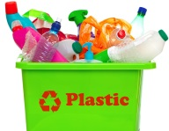

Plastics are divided into two groups, **THERMOPLASTICS** ( can be softened by heating and hardened by cooling- it can be reshaped) and **THERMOSETTING PLASTICS** ( hardens permanently can’t be reshaped, can endure high temperatures), depending on their reaction to heat.

**Name 10 items that are made of plastic.**

|  |
| --- |
|  |

**SMART MATERIALS** 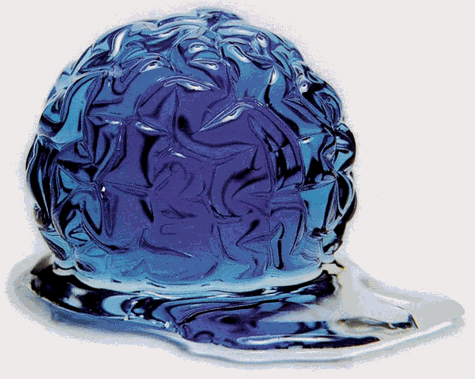

<http://www.youtube.com/watch?v=FgrIDibPmJo> 2,57

Science and technology have made amazing developments in the design of electronics and machinery using standard materials, which do not have particularly special properties. Some such materials have the ability to change shape or size simply by adding a little bit of heat, or to change from a liquid to a solid almost instantly when near a magnet; these materials are called smart materials.

Suggest what smart materials can be used for: _______________________________________________________

**Task 3A Read and learn**

**PROPERTIES OF MATERIALS**

When materials are exposed to forces, such as **tension** (stretching forces 🡨 🢭🡪) and **compression** (crushing forces 🡪 🢭 🡨 ), they **deform**- that is, they change shape.

When material is subjected to tension, its length will increase by a certain amount. This is called **extension**. The **tensile strength** (ability to resist tension) is usually lower than its **compressive strength** ( ability to resist compression).

1. **ELASTICITY AND PLASTICITY**

Some materials **can extend** significantly, but can still return to their original shape. It’s called **elasticity**. Rubber is very elastic.

If material has low elasticity, and is **strong**, we call them **stiff**.

If material has low elasticity and is **weak**, it is **brittle**- it **fractures** (breaks) very easily. ( glass).

Some material change shape, but do not return to their original shape. They are **plastic materials**.

A material that can be plastically deformed by **hammering or rolling** ( example, lead) is **malleable**. A material that can be **drawn out**( stretched) into a long length ( copper) is **ductile.**

1. **HARDNESS**

The hardness of a material affects its **durability**- that is, how long it will last. Generally **hard** materials are more durable than **soft** materials, because they are better at **resisting wear** to their surfaces. Hardness can be defined in two main ways:

* **stratch hardness**: a material’s ability to resist being scratched.

Materials with high degree of scratch hardness are said to have goo abrasion resistant

* **Indentation hardnes**s describes a material’s ability to resist indentations

1. **FATIGUE, FRACTURE AND CREEP**

**Fatigue** is usually caused by **cyclic loads**- forces that continually vary (plane- wings are affected by cyclic loading as the frequently **flex**). The consequence of fatigue is **micro-cracking**, the formation of crack too small to see with the eye, and which worsen over time. The speed at which fatigue cracking progresses depends on the material’s fracture **toughness**.

**Creep** means that components become **permanently deformed** (stretched, for example) due to loads. Creep increases over time (engines, where load and temperatures are high)

**Task 3A TRANSLATE from the *PROPERTIES OF MATERIALS* chapter**

|  |  |
| --- | --- |
|  | trpežnost |
|  | obraba |
|  | odpornost na podrgnine, brušenje |
|  | odpornost na zareze |
|  | odpornost na praske |
|  | utrujenost |
|  | žilavost, lomna odpornost |
|  | poslabšati |
|  | območje plastičnosti |
|  | ponavljajoča obremenitev |
|  | spreminjati se |

**Task 3B Translate some more…**

|  |  |
| --- | --- |
| conductive (allows heat or current to flow easily)  conductivity  a conductor | *prevoden*  *prevodnost*  *prevodnik* |
| to insulate (does not allow heat or current to flow easily)  insulation  insulator |  |
| conductor ≠ insulator |  |
| light ≠ heavy |  |
| transparent ≠ opaque |  |
| flammable ≠ non-flammable |  |
| waterproof ≠ absorbent |  |
| flexible ≠ rigid |  |
| magnetic ≠ non-magnetic |  |
| elastic ≠ plastic |  |
| soft ≠ hard, tough |  |
| styrofoam, polystyrene |  |
| cast iron |  |
| reinforced concrete |  |
| brass |  |
| corrosion resistant |  |
| flexible, flexibility |  |
| durable, durability |  |
| flexible, flexibility |  |
| transparent, transparency |  |
| malleable. malleability |  |
| ductile, ductility |  |
| elastic, elasticity |  |

**Task 3C Work in groups. Design a chair or an xy…** PS Presentation can be graded.

**Write, explain and describe your ides in class. Use the following words and phrases.**

|  |  |
| --- | --- |
| **Our main idea was to …**  **Our design consists of …**  **It is constructed of…**  **It consists of/is made of**  **Its measurements are..**  **We decided to use … because…**  **It can be used for …**  **The (dis)advantage of the material we used is …** |  |

**Task 3D** **Answer the questions.**

1. What are water pipes made of? Why?
2. What material is best for connecting a socket to the electricity supply?
3. What is best for making a bicycle frame?
4. What material is best for television casings?

**Task 3E Find the opposites**

|  |  |
| --- | --- |
| 1. breaks easily |  |
| 1. clear |  |
| 1. easy to shape |  |
| 1. hard/tough |  |
| 1. light |  |
| 1. strong |  |
| 1. flammable |  |
| 1. absorbent |  |
| 1. elastic |  |
| 1. conductor |  |
| 1. rigid |  |
| 1. magnetic |  |
| 1. transparent |  |
| 1. strong |  |

**Task 4** **WRITING ( 80 words).What in your opinion is the material of the future? Give two reasons for your choice. Name objects and explain their usage.**

**Task 5 CROSSWORDS**

|  |  |
| --- | --- |
| **Across**  **3.** širjenje  4. plastičnost  6. obstojen  12. zlomiti  14. železobeton  15. svinec  17. elastičnost  19. prozoren  24. jeklene zlitine  25. rjavenje  26. trdnost | **Down**  1. utrujenost materiala  2. vnetljiv  5. območje plastičnosti  7. krhek  8. lastnost  9. kovina  10. preoblikovati, deformirati  11. vdrtina  13. napetost  16. lito železo  18. spojina  20. stiropor  21. vodoodporen  22. trdnost, odpornost  23. stekleno vlakno  25. prevodnik  27. zlitina  28. praska |

# MATERIALS AND PROPERTIES

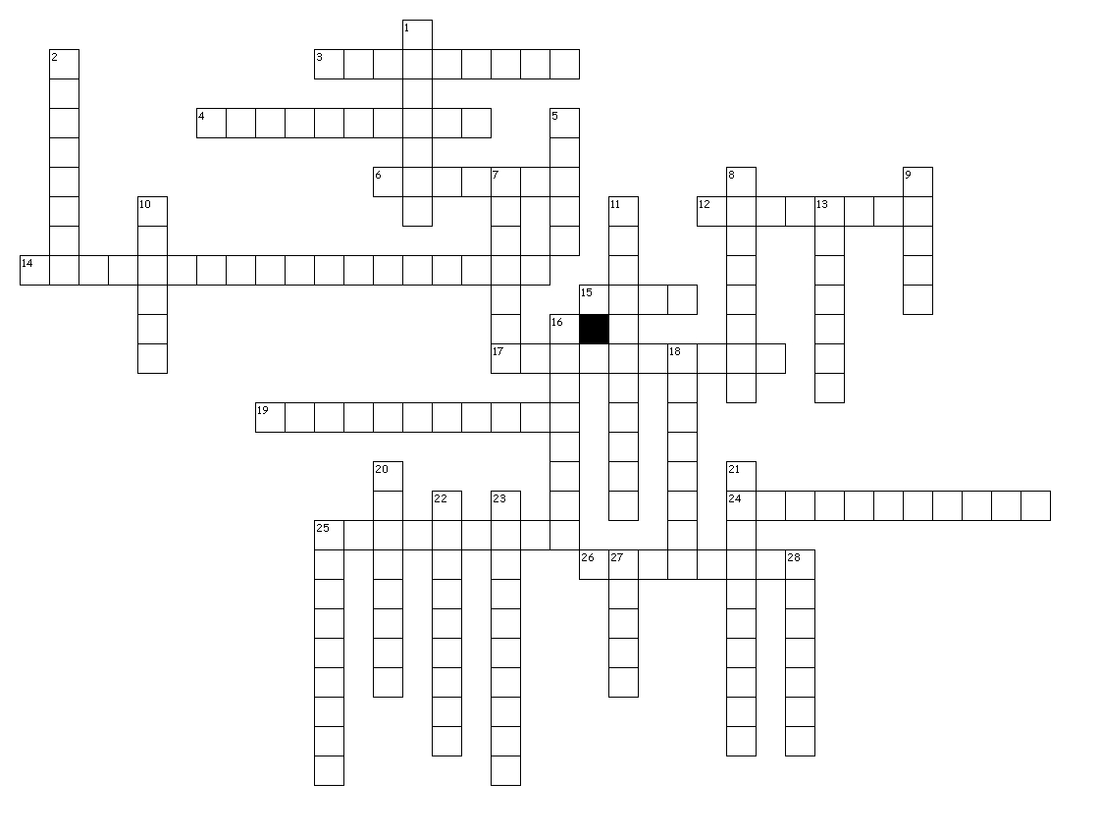

Additional links:

<http://www.youtube.com/watch?v=SVlTtq3uOdY> 1 min Physical properties of materials

<http://www.youtube.com/watch?v=kzAN5f0m5H4&feature=related> 2 min Interesting facts about aluminium

<http://curiosity.discovery.com/question/key-properties-of-aluminum> 2,51 Discovery channel, aluminium

<http://curiosity.discovery.com/question/material-used-to-make-sword> 2,03, Discovery channel, What metals are used to make swords

<http://curiosity.discovery.com/question/how-magical-is-corrosion> 2 min, Discovery channel, How magical is corrosion

<http://curiosity.discovery.com/question/properites-element-change-small-samples> 1,38 , Discovery channel, Can properties change in small quantities